**FREE WEBINAR # 04**

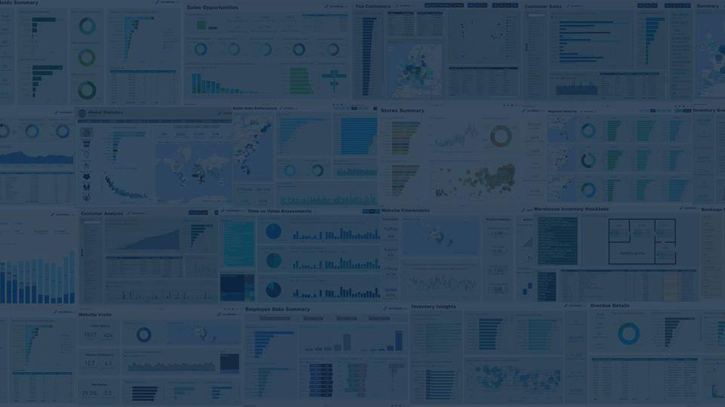

# Internal Audit Dashboard in Power BI

#### Presented by: Muhammad Kashif

**3rd Oct 2020**

**IMPORTANT NOTE**

* **Demo Dataset is already emailed to all the registered participants.**
* **After the Webinar, Participants material (including PPT and PBIX file) will be emailed to registered participants.**
* **Others may email us at** [**trainings@kaizenanalytic.pk**](mailto:trainings@kaizenanalytic.pk) **to request for participants material.**
* **Leave your comments in the chat and our team will answer it on the spot.**

## ABOUT ME

* **Member of Institute of Cost and Management of Pakistan (Qualified in 2005)**
* **Over 16 years of experience in 360 degree Areas of Finance**

(Data Analytics, Corporate/Public Finance, Internal Audit, Business Process, Finance Modelling, and Capacity Development)

* **Founder of Kaizen Analytic LLP**

 <https://www.linkedin.com/in/muhammad-kashif-aa40556/> <https://www.facebook.com/KaizenAnalytic>

 [ceo@kaizenanalytic.pk](mailto:ceo@kaizenanalytic.pk)

## TODAY’S WEBINAR

* **Section 1: Internal Audit Universe**
* **Section 2: Demo Dataset**

#### Expense Analysis

* + **Internal Audit Dashboard**
* **Section 3: Way Forward - Advance Financial Analytics and Details**

**Section 1**

**Internal Audit Universe**



### What is Internal Audit?

Internal Audit is an independent, objective, assurance to add value to and improves an organization’s operations.

It is disciplined approach to evaluate and improve the effectiveness of Risk Management , Control and governance processes.

*Source : The Institute of Internal Auditors*



### Internal Audit Mitigate the Enterprise Risk

Operational Compliance



Strategic

Financial

* + People Risk
* Governance Risk
* Planning & Resource

Allocation Risk

* Technology Change Risk
* Customer Demand Change Risk
* Competition Risk
* Enterprise Portfolio

Risk

* Government Policy Risk
* Political Risk
* Business Development Risk
  + Project Management Risk
  + External Risk
  + IT and Control

Risk

* + Communication Risk
  + Investor Relations Risk
  + Organizational Structure Risk
  + Major Initiative Risk
* Code of Conduct Risk
* Legal Risk



* Cost Recovery Risk
* Financial Accounting and Reporting Risk
* Liquidity, Credit

and Equity Risk

* Cash Flow Risk
* Profitability Risk
* Market Sensitivity Risk
* Volume Risk
* Market Liquidity Risk
* Regulatory Risk
* Internal Control Risk
* Management

Internal Audit Plan

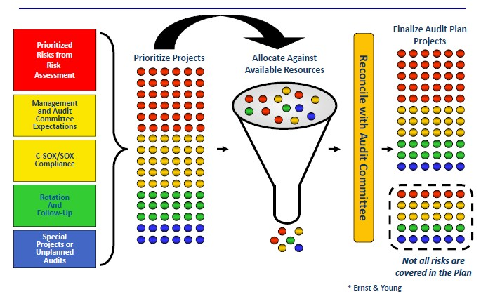



Source : An Innovative Internal Audit Plan

**Section 2**

**Expense Analysis Internal Audit Dashboard with Demo Dataset**



## Key Pillars of Power BI

Level

* Data Transformation Beginner
* Data Modeling Beginner
* DAX Functions Beginner
* Data Visualization Intermediate



## Download Power BI

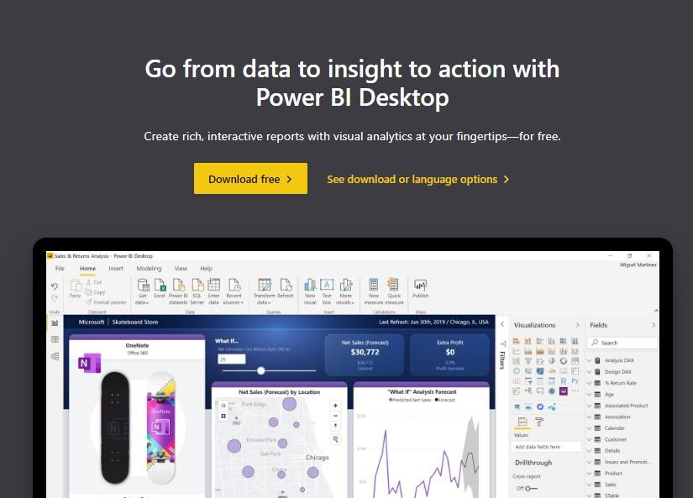

* Download Link

https://powerbi.microsoft.com/en-us/desktop/

* Review the Dataset
* Move to Power BI

**Section 3**

**Way Forward Advance Financial Analytics**

**and Details**



**Premium Training Workshops**

**Dynamic Financial Decision in Power BI Advance Financial Reporting in Power BI**



# Dynamic Financial Decision in Power BI



Int’l Live Training Workshop (2nd Batch)

Dynamic Financial Decision in Power BI



* + 12 hours spread over 3 days
    - Friday Evening and
    - Saturday & Sunday Full Day
  + Participatory Method of Training
  + Descriptive and Diagnostic Analytics
  + Delivered through Zoom platform
  + Practical Implementation of Learning.

30% OFF

In Oct 2020 ONLY

Int’l Live Training Workshop (2nd Batch)

### Dynamic Financial Decision in Power BI



**DATE AND TIME**

Fri – 9th Oct 2020 6-8 PM (PST)

Sat- 10th Oct 2020 10 AM – 1 PM

2PM – 5 PM Sun- 11th Oct 2020 10 AM – 1 PM

2PM – 5 PM (Reserve)

30% OFF

In Oct 2020 ONLY



# Advance Financial Reporting

**in Power BI**



Int’l Live Training Workshop (5th Batch)

Advance Financial Reporting in Power BI



* + 12 hours spread over 3 days
    - Friday Evening and
    - Saturday Full Day
  + Participatory Method of Training
  + Descriptive and Diagnostic Analytics
  + Delivered through Zoom platform
  + Practical Implementation of Learning.

30% OFF

In Oct 2020 ONLY

Int’l Live Training Workshop (5th Batch)

### Advance Financial Reporting in Power BI



**DATE AND TIME**

Fri – 16th Oct 2020 6-8 PM (PST)

Sat- 17th Oct 2020 10 AM – 1 PM

2PM – 5 PM Sun- 18th Oct 2020 10 AM – 1 PM

2PM – 5 PM (Reserve)

30% OFF

In Oct 2020 ONLY



#### OUR TRAINING METHODOLOGY

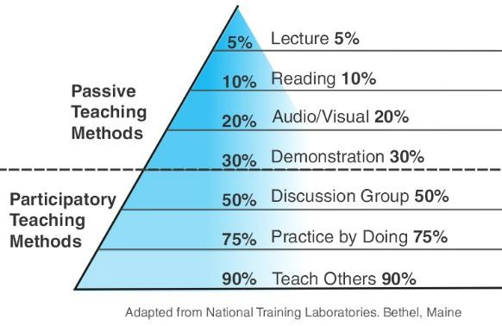

**OUR TRAINING METHODOLOGY**





**Learning on Demo Dataset**

**Participants will learn techniques with Trainer**



**Learning by Implementation**

**Participants will choice ONE DASHBOARD for professional reporting**

**Trainer will ASSIST participants in creating Dynamic Reporting in Power BI**

Contact us:

**KAIZEN ANALYTIC LLP**

Office 53, M-2, Eden Tower, Main Boulevard Road Gulberg III

Lahore

[trainings@kaizenanalytic.pk](mailto:trainings@kaizenanalytic.pk)

+92-331-9664911

THANK YOU

Connect to Trainer

 <https://www.linkedin.com/in/muhammad-kashif-aa40556/>

Connect to Power BI for Finance and Business Professionals

 http[s://ww](http://www.linkedin.com/groups/12459235/)w[.lin](http://www.linkedin.com/groups/12459235/)k[edin.com/](http://www.linkedin.com/groups/12459235/)gr[oups/12459235/](http://www.linkedin.com/groups/12459235/)

Connect to Us

 <https://www.linkedin.com/company/kaizen-analytic>

 <https://www.facebook.com/KaizenAnalytic>

Email to us

 [trainings@kaizenanalytic.pk](mailto:trainings@kaizenanalytic.pk)